

DCN

Assignment - 5



3152 Hardik TOgadiya

**1. Write a java program to implement Mono-Alphabetic Cipher with Key-String using TCP.**

import java.io.\***;**import java.net.\***;**import java.util.Scanner**;**class p1_client {  
 public static void main(String[] args) throws Exception {  
 try {  
 Socket socket = new Socket("localhost"**,** 6000)**;** DataOutputStream ostream = new  
 DataOutputStream(socket.getOutputStream())**;** DataInputStream instream = new  
 DataInputStream(socket.getInputStream())**;** Scanner sc = new Scanner(System.in)**;** String data = "abcdefghijklmnopqrstuvwxyz"**;** String key = "qwertyuiopasdfghjklzxcvbnm"**;** System.out.print("Enter Data to send: ")**;** String msg = sc.nextLine()**;** String sendmsg = ""**;** char ch**;** for (int i = 0**;** i < msg.length()**;** i++) {  
 ch = msg.charAt(i)**;** int index = data.indexOf(ch)**;** sendmsg += key.charAt(index)**;** }  
 ostream.writeUTF(sendmsg)**;** System.out.println("Encrypted = " + sendmsg)**;** instream.close()**;** ostream.close()**;** socket.close()**;** } catch (Exception e) {  
 System.out.println(e)**;** }  
 }  
}

import java.io.\***;**import java.net.\***;**import java.util.Scanner**;**class lass p1_server {  
 public static void main(String[] args) throws Exception {  
 try {  
 ServerSocket serversocket = new ServerSocket(6000)**;** System.out.println("server is listening on localhost:6000")**;** Socket socket = serversocket.accept()**;** DataInputStream instream = new DataInputStream(socket.getInputStream())**;** DataOutputStream ostream = new DataOutputStream(socket.getOutputStream())**;** String data = "abcdefghijklmnopqrstuvwxyz"**;** String key = "qwertyuiopasdfghjklzxcvbnm"**;** String rmsg = instream.readUTF()**;** System.out.println("\nReceived msg = " + rmsg)**;** String final_msg = new String()**;** for (int i = 0**;** i < rmsg.length()**;** i++) {  
 char ch = rmsg.charAt(i)**;** int index = key.indexOf(ch)**;** final_msg += data.charAt(index)**;** }  
 System.out.println("Decrypted msg = " + final_msg)**;** ostream.close()**;** instream.close()**;** socket.close()**;** serversocket.close()**;** } catch (Exception e) {  
 System.out.println(e)**;** }  
 }  
}

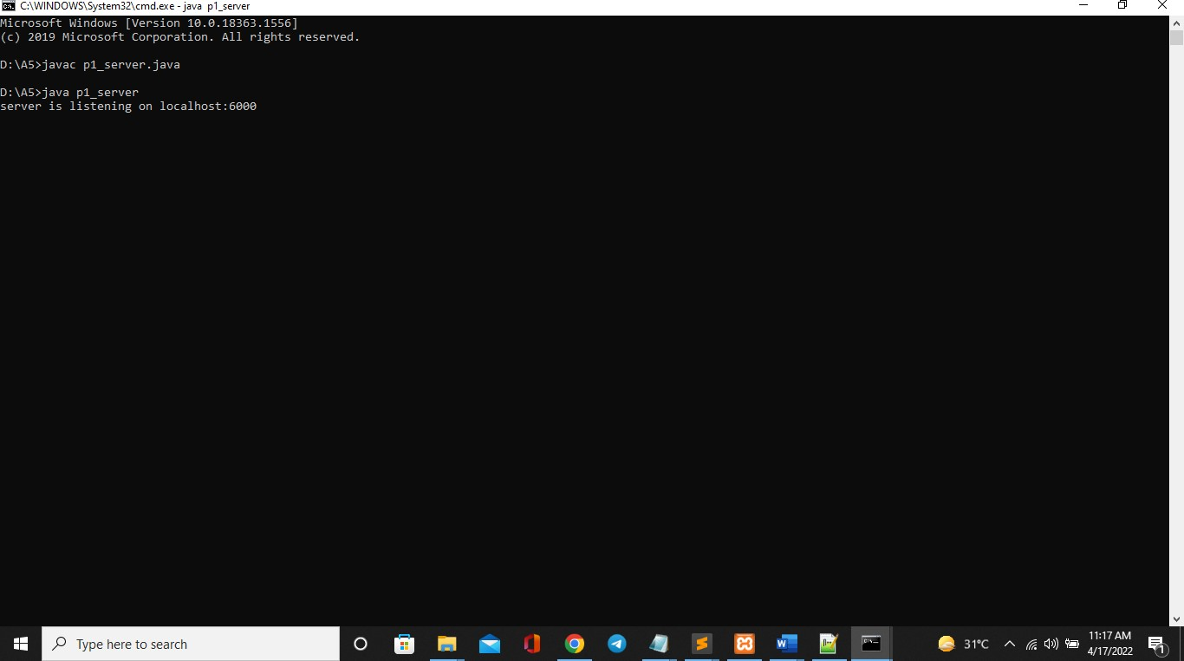

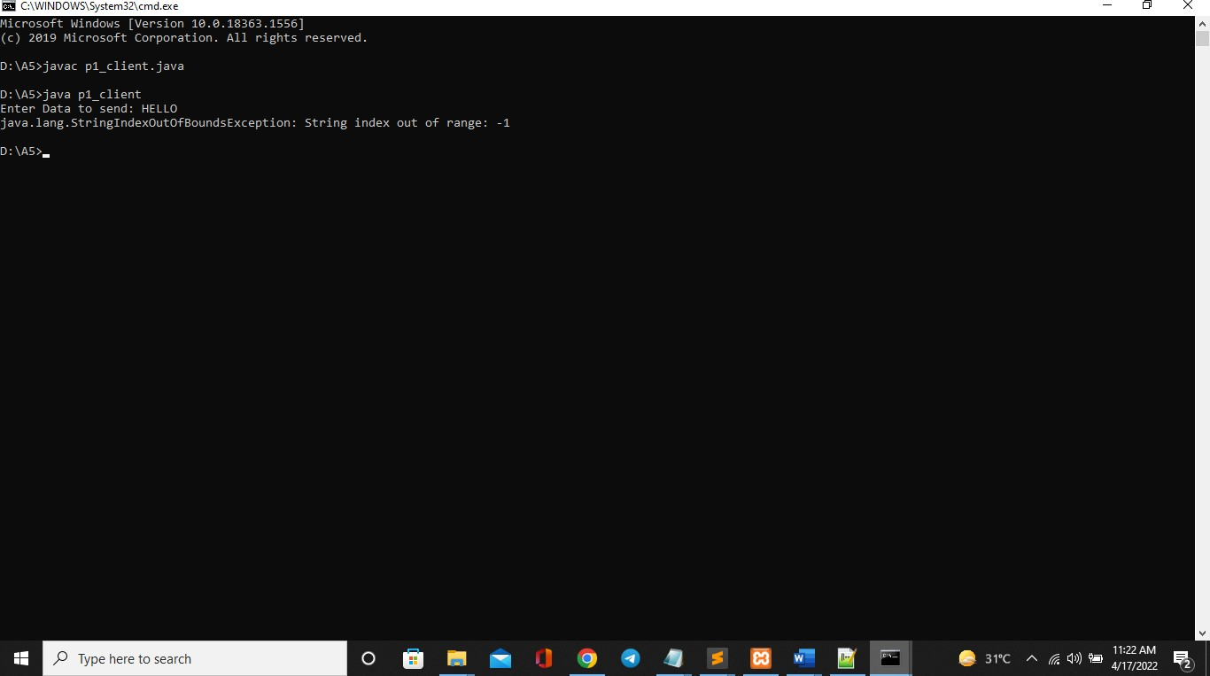

**2. Write a java program to implement Caesar Cipher using TCP.**

import java.io.\***;**import java.net.\***;**import java.util.Scanner**;**class p2_client {  
 public static void main(String[] args) throws Exception {  
 try {  
 Socket socket = new Socket("localhost"**,** 6000)**;** DataOutputStream ostream = new DataOutputStream(socket.getOutputStream())**;** DataInputStream instream = new DataInputStream(socket.getInputStream())**;** Scanner sc = new Scanner(System.in)**;** String data = "abcdefghijklmnopqrstuvwxyz"**;** int key = 2**;** System.out.print("Enter Data to send: ")**;** String msg = sc.nextLine()**;** String sendmsg = ""**;** for (int i = 0**;** i < msg.length()**;** i++) {  
 char ch = msg.charAt(i)**;** if (ch == 'y') {  
 sendmsg += 'a'**;** } else if (ch == 'z') {  
  
  
 } else {  
  
  
 }  
 }  
  
 sendmsg += 'b'**;** int index = data.indexOf(ch)**;** sendmsg += data.charAt(index + key)**;** ostream.writeUTF(sendmsg)**;** System.out.println("\nEncrypted = " + sendmsg)**;** 3111 - Kumbhani Sanket  
  
  
 instream.close()**;** ostream.close()**;** socket.close()**;** } catch (Exception e) {  
 System.out.println(e)**;** }  
 }  
}  
  
  
 import java.io.\***;**import java.net.\***;** import java.util.Scanner**;**class p2_server {  
 public static void main(String[] args) throws Exception {  
  
 try {  
  
  
 ServerSocket serversocket = new ServerSocket(6000)**;** System.out.println("server is listening on localhost:6000")**;** Socket socket = serversocket.accept()**;** DataInputStream instream = new DataInputStream(socket.getInputStream())**;** DataOutputStream ostream = new DataOutputStream(socket.getOutputStream())**;** String data = "abcdefghijklmnopqrstuvwxyz"**;** int key = 2**;** String rmsg = instream.readUTF()**;** System.out.println("\nReceived msg = " + rmsg)**;** String final_msg = new String()**;** for (int i = 0**;** i < rmsg.length()**;** i++) {  
 char ch = rmsg.charAt(i)**;** if (ch == 'a') {  
 final_msg += 'y'**;** } else if (ch == 'b') {  
  
  
 } else {  
  
  
 }  
 }  
  
 final_msg += 'z'**;** int index = data.indexOf(ch)**;** final_msg += data.charAt(index - key)**;** System.out.println("\nDecrypted msg = " + final_msg)**;** ostream.close()**;** instream.close()**;** socket.close()**;** serversocket.close()**;** } catch (Exception e) {  
 System.out.println(e)**;** }  
 }  
}

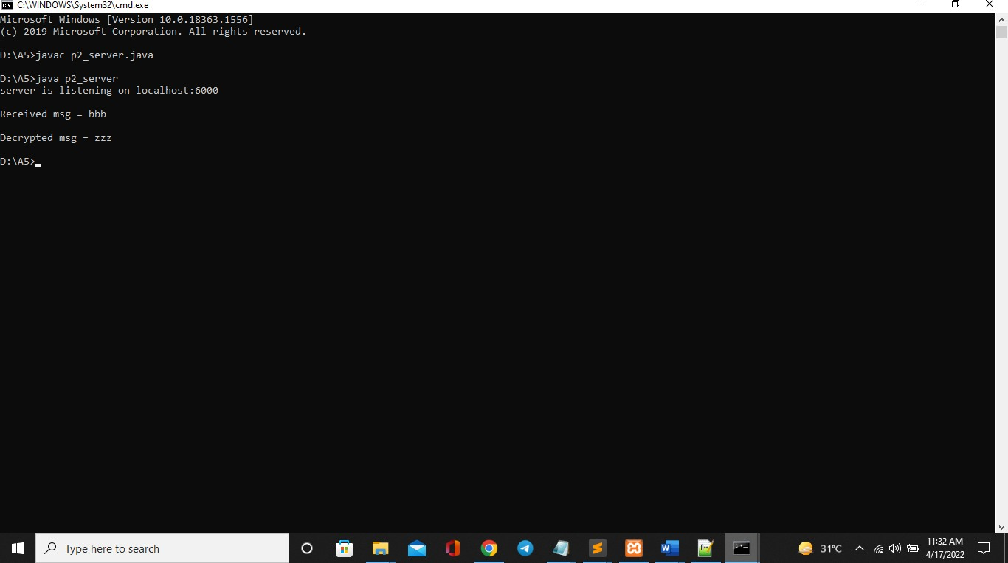

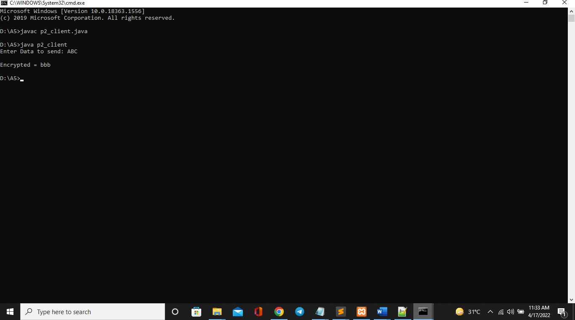

**3. Write a java program to implement Rail-Fence Cipher using UDP.**

import java.net.\***;** import java.io.\***;**import java.util.Scanner**;**class p3_client  
{  
 public static void main(String args[]) throws Exception  
 {  
 try{  
 DatagramSocket ds1 = new DatagramSocket()**;** String msg = "helloworld"**;** System.out.println("Plain msg = "+ msg)**;** String one = ""**;** String two = ""**;** for(int i=0**;**i<msg.length()**;**i++)  
 {  
 if(i%2==0)  
 one += msg.charAt(i)**;** else  
 two += msg.charAt(i)**;** }  
 System.out.println("one = "+one)**;** System.out.println("two = "+two)**;** String cmsg = one + two **;** System.out.println("\ncipher msg = "+ cmsg)**;** InetAddress ip = InetAddress.getByName("localhost")**;** DatagramPacket dp1 = new DatagramPacket(cmsg.getBytes()**,**cmsg.length()**,**ip**,**6363)**;** ds1.send(dp1)**;** DatagramSocket ds2 = new DatagramSocket(6565)**;** byte[] buf = new byte[500]**;** DatagramPacket dp2 = new DatagramPacket(buf**,**500)**;** ds2.receive(dp2)**;** String msg1 = new String(buf)**;** System.out.println("\nDe-cipher msg: " + msg1)**;** }catch(Exception e)  
 {System.out.println(e)**;**}  
 }  
}  
  
 import java.net.\***;** import java.io.\***;** import java.util.Scanner**;**class p3_server  
{  
 public static void main(String args[]) throws Exception  
 {  
 try{  
 DatagramSocket ds1 = new DatagramSocket(6363)**;** byte[] buf = new byte[500]**;** DatagramPacket dp1 = new DatagramPacket(buf**,**500)**;** ds1.receive(dp1)**;** ds1.close()**;** String cmsg = new String(dp1.getData()**,**0**,**dp1.getLength())**;** System.out.println("Received msg = " + cmsg)**;** DatagramSocket ds2 = new DatagramSocket()**;** String a = cmsg.substring(0**,**cmsg.length()/2)**;** String b = cmsg.substring(cmsg.length()/2**,**cmsg.length())**;** String dcmsg = ""**;** for(int i=0**,**x=0**,**y=0**;** i<cmsg.length()**;**i++)  
 {  
 if(i%2 == 0)  
 {  
 dcmsg += a.charAt(x)**;** x++**;** }  
 else  
 {  
 dcmsg += b.charAt(y)**;** y++**;** }  
 }  
 System.out.println("\nDe-cipher msg = "+ dcmsg)**;** InetAddress ip = InetAddress.getByName("localhost")**;** DatagramPacket dp2 = new   
 DatagramPacket(dcmsg.getBytes()**,**dcmsg.length()**,**ip**,**6565)**;** ds2.send(dp2)**;** }catch(Exception e)  
  
 {System.ou

t.println(e)**;**}  
 }  
}

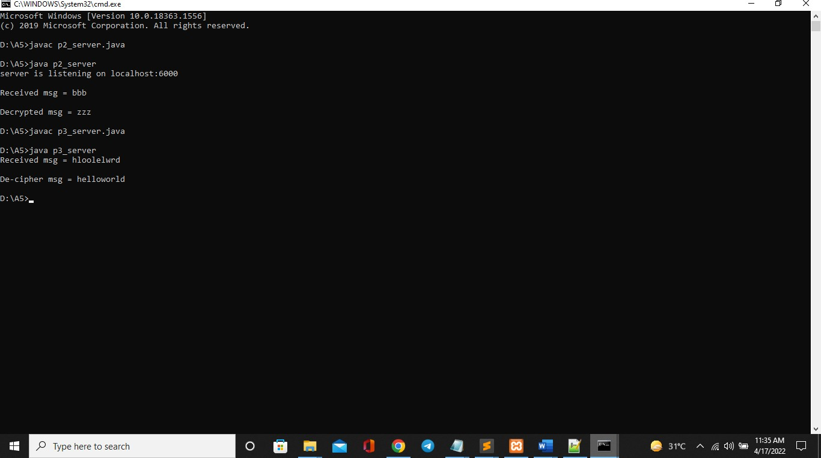

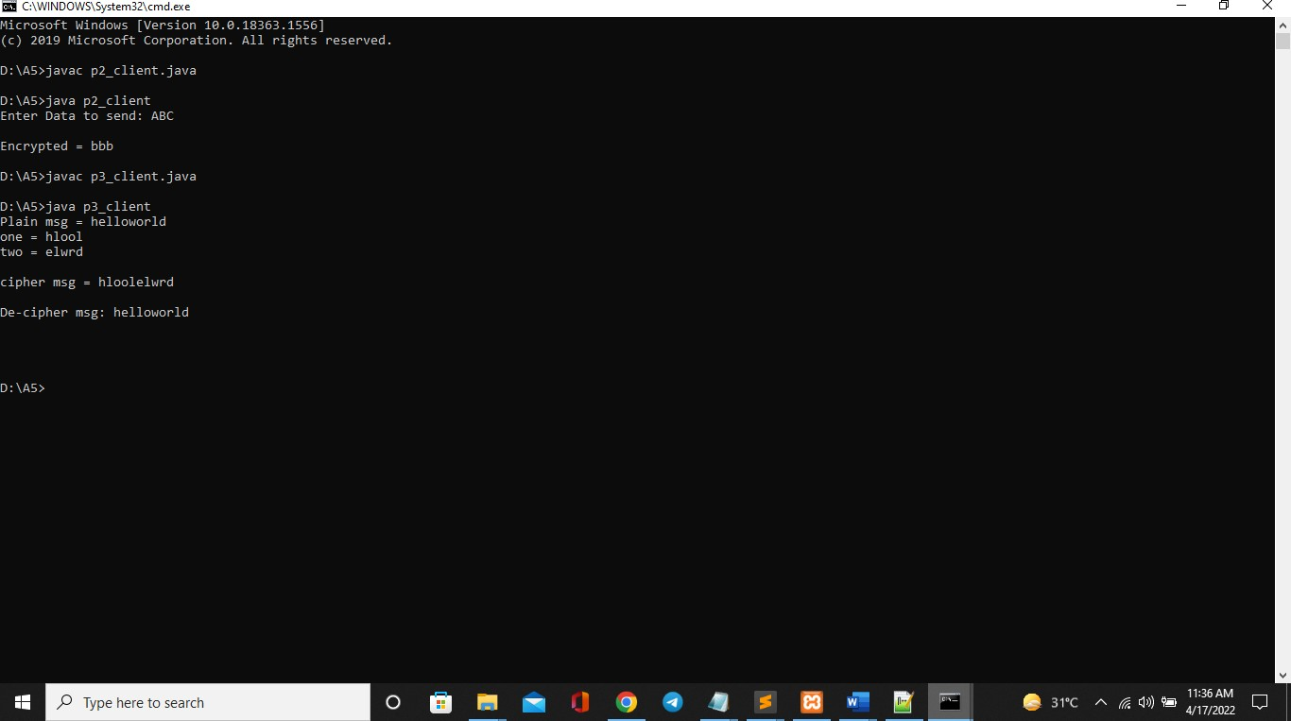

**4. Write a java program to implement Vigenere Cipher using UDP.**

import java.net.\***;** import java.io.\***;**import java.util.Scanner**;**class p4_client  
{  
  
 public static void main(String args[]) throws Exception  
 {  
 try{  
 DatagramSocket ds1 = new DatagramSocket()**;** Scanner sc = new Scanner(System.in)**;** System.out.print("Enter msg = ")**;** String msg = sc.nextLine()**;**// System.out.print("Enter Key = ");  
// String key = sc.nextLine(); String key = "dcn";  
// System.out.println("msg = "+ msg); System.out.println("key = "+ key);  
 int x=0**;** while(key.length()<msg.length())  
 {  
 key += key.charAt(x)**;** x++**;** }  
 System.out.println("New key = "+ key)**;**// cipher process  
  
 String cmsg = ""**;** for(int i=0**;**i<msg.length()**;**i++)  
 {  
 int cno = (msg.charAt(i)-97 + key.charAt(i)-97) % 26 **;** cno += 97**;** cmsg += (char)cno**;** }  
 System.out.println("\nCipher msg = "+ cmsg)**;** InetAddress ip = InetAddress.getByName("localhost")**;** DatagramPacket dp1 = new DatagramPacket(cmsg.getBytes()**,**cmsg.length()**,**ip**,**6363)**;** ds1.send(dp1)**;** DatagramSocket ds2 = new DatagramSocket(6565)**;** byte[] buf = new byte[500]**;** DatagramPacket dp2 = new DatagramPacket(buf**,**500)**;** ds2.receive(dp2)**;** String msg1 = new String(buf)**;** System.out.println("\nDe-cipher msg:" + msg1)**;** }catch(Exception e)  
 {System.out.println(e)**;**}  
 }  
}  
  
 import java.net.\***;** import java.io.\***;** import java.util.Scanner**;**class p4_server  
{  
 public static void main(String args[]) throws Exception  
 {  
  
 try{  
 DatagramSocket ds1 = new DatagramSocket(6363)**;** byte[] buf = new byte[500]**;** DatagramPacket dp1 = new DatagramPacket(buf**,**500)**;** ds1.receive(dp1)**;** ds1.close()**;** String rmsg = new String(dp1.getData()**,**0**,**dp1.getLength())**;** System.out.println("\nReceived msg = " + rmsg)**;** DatagramSocket ds2 = new DatagramSocket()**;** String key = "dcn"**;** int x=0**;** while(key.length()<rmsg.length())  
 {  
 key += key.charAt(x)**;** x++**;** }  
 String dcmsg = ""**;** for(int i=0**;**i<rmsg.length()**;**i++)  
 {  
 int cno = ((rmsg.charAt(i)-97) - (key.charAt(i)-97) + 26) % 26 **;** cno += 97**;** dcmsg += (char)cno**;** }  
 System.out.println("\nDe-cipher msg = "+dcmsg)**;** InetAddress ip = InetAddress.getByName("localhost")**;** DatagramPacket dp2 = new  
 DatagramPacket(dcmsg.getBytes()**,**dcmsg.length()**,**ip**,**6565)**;** ds2.send(dp2)**;** }catch(Exception e)  
 {System.out.println(e)**;**}  
 }  
}

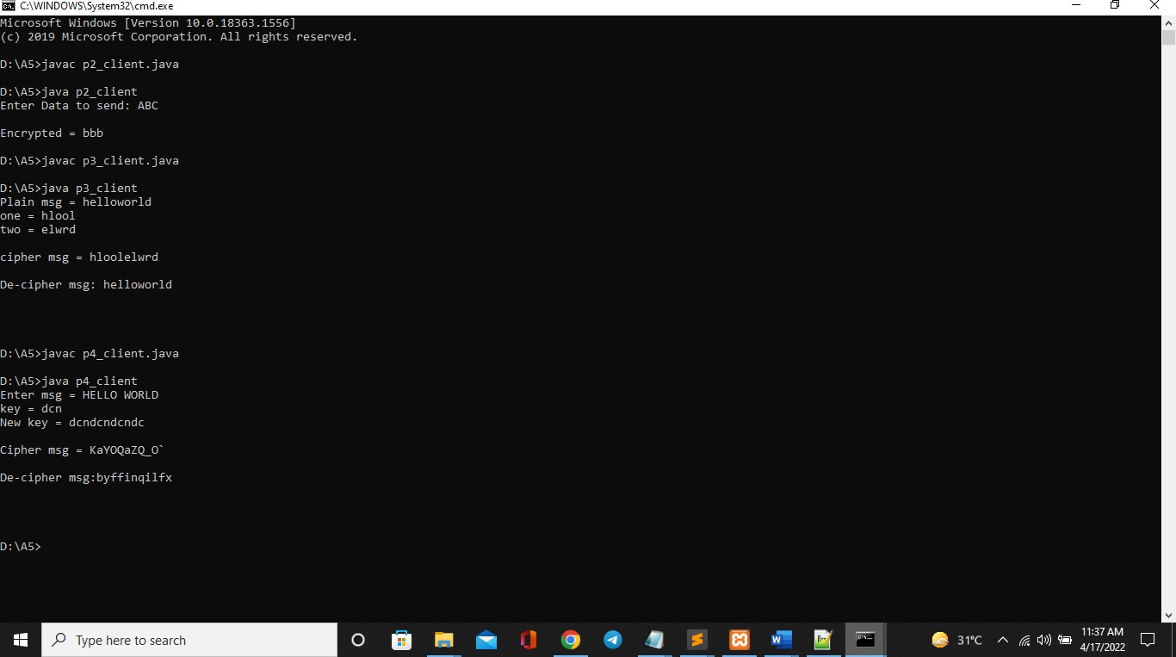

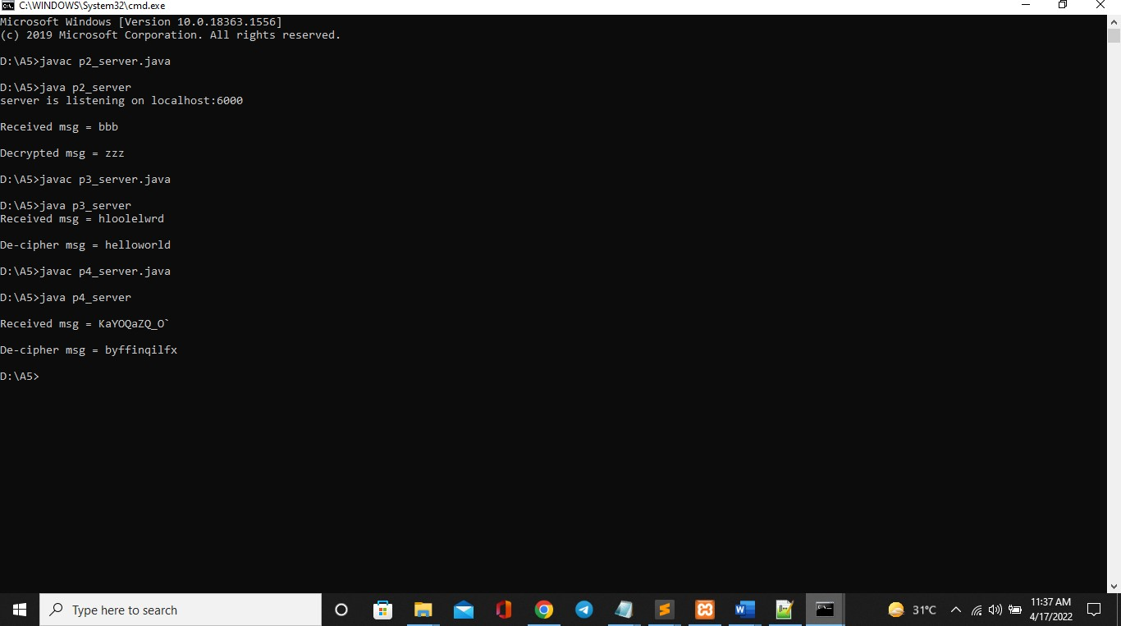

**5. Write a java program to implement DES Algorithm with help of Java Cryptography packages using TCP.**

import java.io.\***;** import java.net.\***;**import java.util.Scanner**;** import java.security.\***;** import javax.crypto.\***;** import javax.crypto.spec.\***;**class p5_client  
{  
 public static void main(String[] args) throws Exception  
  
 {  
 try  
 {  
 Socket socket = new Socket("localhost"**,**6000)**;** DataOutputStream ostream = new DataOutputStream(socket.getOutputStream())**;** DataInputStream instream = new DataInputStream(socket.getInputStream())**;** Scanner sc = new Scanner(System.in)**;** System.out.print("Enter msg: ")**;** String msg = sc.nextLine()**;**//key generate  
 String kstring = "sahildcn"**;** SecretKey key = new SecretKeySpec(kstring.getBytes()**,**"DES")**;** Cipher cipher = Cipher.getInstance("DES/ECB/PKCS5Padding")**;** cipher.init(Cipher.ENCRYPT_MODE**,**key)**;** String cmsg = new String(cipher.doFinal(msg.getBytes()))**;** ostream.writeUTF(cmsg)**;** System.out.println("\nCipher msg = "+ cmsg)**;** instream.close()**;** ostream.close()**;** socket.close()**;** }  
 catch(Exception e)  
  
 {  
 System.out.println(e)**;** }  
  
 }  
}  
  
  
  
  
Server..  
  
 import java.io.\***;** import java.net.\***;** import java.util.Scanner**;** import java.security.\***;** import javax.crypto.\***;** import javax.crypto.spec.\***;**class p5_server  
{  
 public static void main(String[] args) throws Exception  
 {  
  
 try  
 {  
 ServerSocket serversocket = new ServerSocket(6000)**;** System.out.println("server is listening on localhost:6000")**;** Socket socket = serversocket.accept()**;** DataInputStream instream = new  
 DataInputStream(socket.getInputStream())**;** DataOutputStream ostream = new DataOutputStream(socket.getOutputStream())**;** String cmsg = instream.readUTF()**;** System.out.println("Received msg = "+cmsg)**;**//key generate  
  
 String kstring = "sahildcn"**;** SecretKey key = new  
 SecretKeySpec(kstring.getBytes()**,**"DES")**;** Cipher cipher = Cipher.getInstance("DES/ECB/PKCS5Padding")**;** cipher.init(Cipher.DECRYPT_MODE**,**key)**;** String dcmsg = new String(cipher.doFinal(cmsg.getBytes()))**;** System.out.println("\nDe-Cipher msg = "+ dcmsg)**;** ostream.close()**;** instream.close()**;** socket.close()**;** serversocket.close()**;** }  
 catch(Exception e)  
 {  
 System.out.println(e)**;** }  
 }  
}

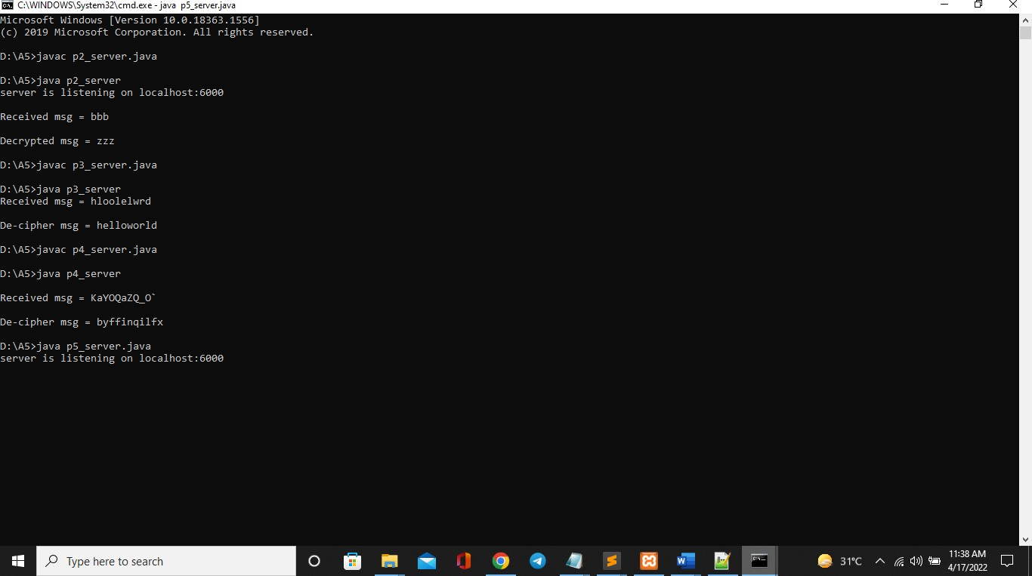

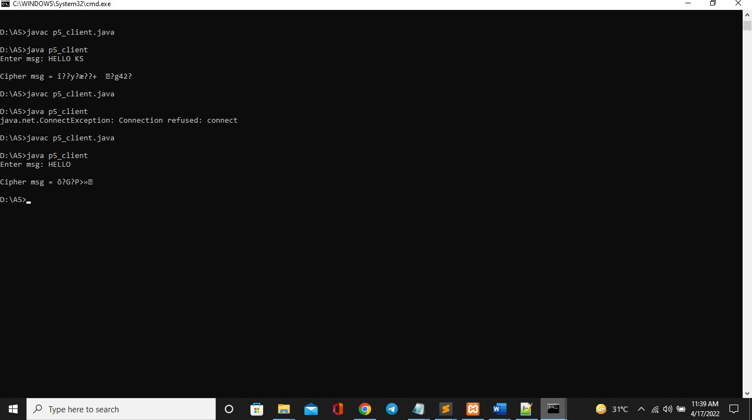

**6. Write a java program to implement AES Algorithm with help of Java Cryptography packages using UDP.**

import java.net.\***;**import java.io.\***;**import java.util.Scanner**;**import java.security.\***;**import javax.crypto.\***;**import javax.crypto.spec.\***;**class p6_client {  
  
 public static void main(String args[]) throws Exception {  
 try {  
 DatagramSocket ds1 = new DatagramSocket()**;** Scanner sc = new Scanner(System.in)**;** System.out.print("Enter msg: ")**;** String msg = sc.nextLine()**;** String kstring = "sahildcnsahildcn"**;** SecretKey key = new SecretKeySpec(kstring.getBytes()**,** "AES")**;** Cipher cipher = Cipher.getInstance("AES/ECB/PKCS5Padding")**;** cipher.init(Cipher.ENCRYPT_MODE**,** key)**;** String cmsg = new String(cipher.doFinal(msg.getBytes()))**;** System.out.println("\nCipher msg = " + cmsg)**;** InetAddress ip = InetAddress.getByName("localhost")**;** DatagramPacket dp1 = new  
 DatagramPacket(cmsg.getBytes()**,** cmsg.length()**,** ip**,** 6363)**;** ds1.send(dp1)**;** DatagramSocket ds2 = new DatagramSocket(6565)**;** byte[] buf = new byte[500]**;** DatagramPacket dp2 = new DatagramPacket(buf**,** 500)**;** ds2.receive(dp2)**;** String msg1 = new String(buf)**;** 3111 - Kumbhani Sanket  
  
 System.out.println("server:" + msg1)**;** } catch (Exception e) {  
 System.out.println(e)**;** }  
 }  
}  
  
 import java.net.\***;**import java.io.\***;** import java.util.Scanner**;**import java.security.\***;** import javax.crypto.\***;**import javax.crypto.spec.\***;**class p6_server {  
 public static void main(String args[]) throws Exception {  
  
 try {  
 DatagramSocket ds1 = new DatagramSocket(6363)**;** byte[] buf = new byte[500]**;** DatagramPacket dp1 = new DatagramPacket(buf**,** 500)**;** ds1.receive(dp1)**;** ds1.close()**;** String cmsg = new String(dp1.getData()**,** 0**,** dp1.getLength())**;** System.out.println("Received msg = " + cmsg)**;** DatagramSocket ds2 = new DatagramSocket()**;** String kstring = "sahildcnsahildcn"**;** SecretKey key = new SecretKeySpec(kstring.getBytes()**,** "AES")**;** Cipher cipher = Cipher.getInstance("AES/ECB/PKCS5Padding")**;** cipher.init(Cipher.DECRYPT_MODE**,** key)**;** String dcmsg = new String(cipher.doFinal(cmsg.getBytes()))**;** System.out.println("\nDe-Cipher msg = " + dcmsg)**;** InetAddress ip = InetAddress.getByName("localhost")**;** DatagramPacket dp2 = new  
 DatagramPacket(dcmsg.getBytes()**,** dcmsg.length()**,** ip**,** 6565)**;** ds2.send(dp2)**;** } catch (Exception e) {  
 System.out.println(e)**;** }  
 }  
}

